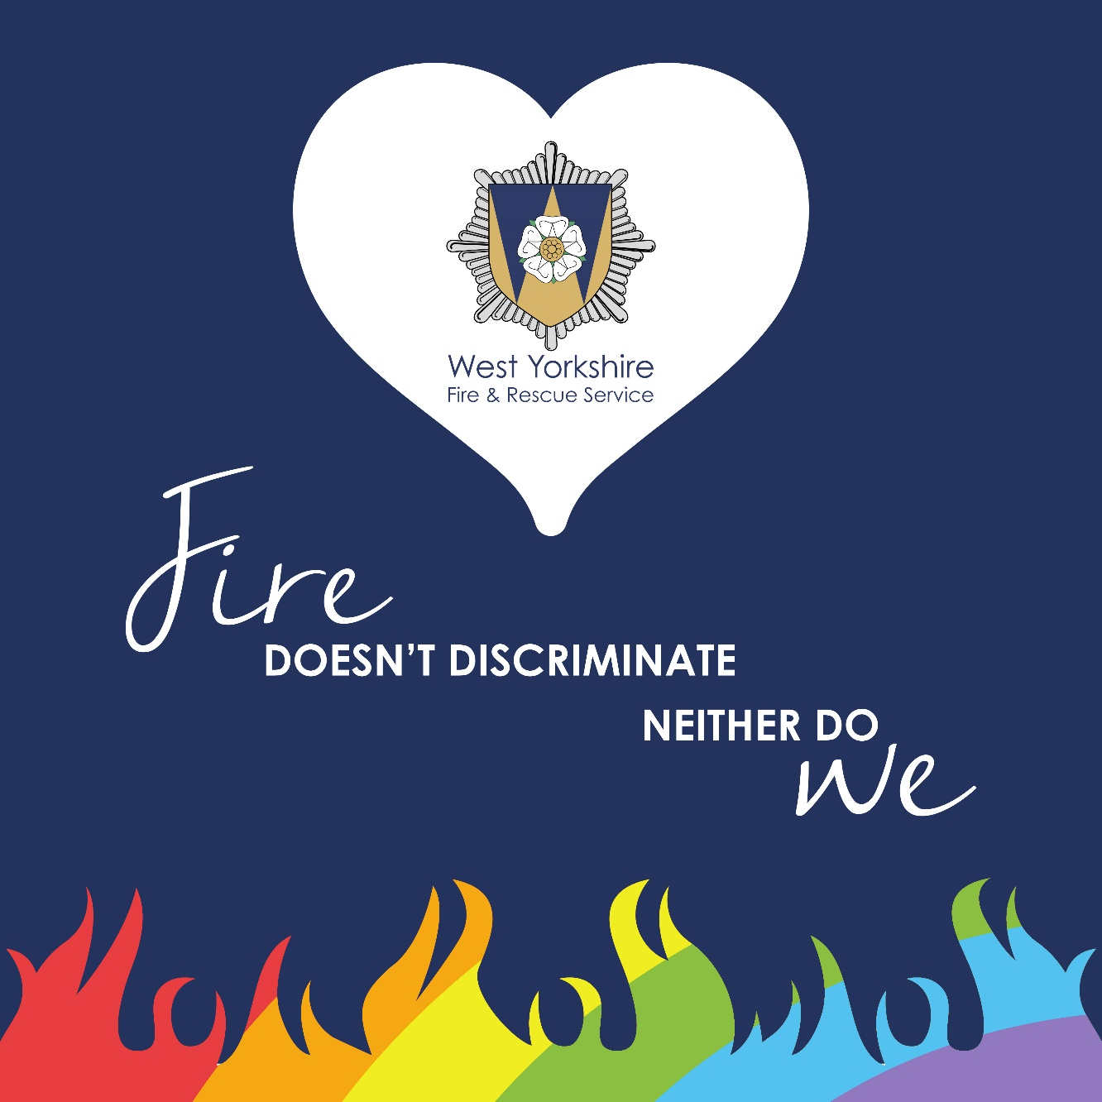

Annual Equality Monitoring Report (2019/20)

Contents

Our Diverse County 3

Why is Diversity and Inclusion important? 4

Why do we collect Equality data? 4

Summary 5

Plans for 2020/21 6

Workforce Diversity 7

Gender 7

Ethnicity 9

Sexual Orientation 11

Disability 13

Age 15

Religion 16

Data Trends and Comparison 17

Grievance and Disciplinary 18

# Our Diverse County

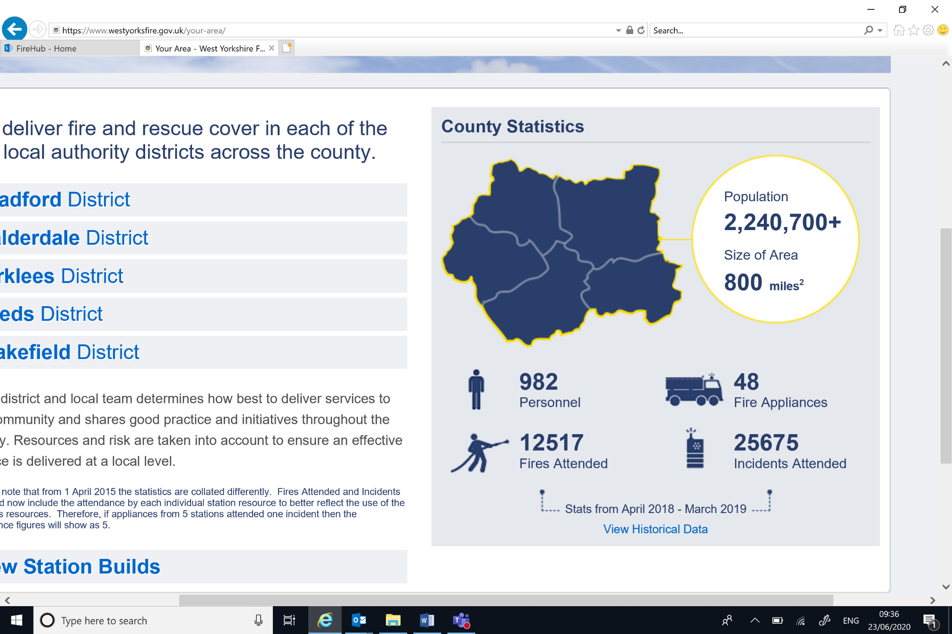

There are 2.2 million people living in the five metropolitan districts of Bradford, Calderdale, Kirklees, Leeds and Wakefield, within an area of 800 square miles. WYFRS provides fire cover 24 hours a day, every day of the year from its 41 stations and Control Centre.

According to the 2011 Census, 18% of West Yorkshire citizens are BAME (Black, Asian, Minority Ethnic). The majority of this population reside in the Bradford region of West Yorkshire which has an Asian population of 20%.

Approximately 18% of the West Yorkshire population are disabled or live with long term illnesses.

The 2011 census indicated that 59.5% of the population of West Yorkshire reported they were Christian. This was followed by those who reported no religion (25.4%). 6.2% of the West Yorkshire population reported that they are Muslim.

1.8% of people in West Yorkshire identify as Lesbian, Gay or Bisexual.

As with most other counties West Yorkshire has gender parity in its population.

WYFRS has a responsibility to serve our communities, but also to reflect the diversity of the population. Understanding the vulnerabilities and related fire risks facing these diverse groups is paramount in meeting these twin obligations.

# Why is Diversity and Inclusion important?

Diversity and inclusion are central to our core values and bring many benefits to our organisation. Having a diverse and inclusive workforce improves team performance, communication, innovation and wellbeing. An inclusive workforce creates individuals who feel confident, valued and able to deliver the best service to our communities and each other. A host of research indicates that diversity at all levels of the organisation, and crucially in key decision making roles leads to more innovation, empathy and ultimately increased organisational performance.

We have an organisational, moral and legal responsibility to promote equality and diversity across all of the protected characteristics: race, sex, disability, age, sexual orientation, religion or belief, gender reassignment, marriage and civil partnerships and pregnancy and maternity.

WYFRS promotes equality of opportunity for all by fostering good relations. We work under the Public Sector Equality Duty to eliminate illegal behaviour such as discrimination, harassment and victimisation.

# Why do we collect Equality data?

WYFRS aspires to reflect the diversity of the communities it serves. In order to demonstrate that we are working towards this, we collect equality data and analyse it. We produce this annual report to present the most recent equality data of the WYFRS workforce. We use this data to inform and direct our projects and initiatives including positive action, recruitment, retention, progression, reasonable adjustments and Equality Impact Assessments.

# Summary

This paper presents the equality data of WYFRS’ workforce at March 2020***.*** Reported information includes workforce profiles by age, gender, ethnicity, disability, religion and sexual orientation for Wholetime, Retained, Control and FRS Support Staff.

At 31st March 2020, WYFRS Workforce diversity is as follows:

* 6% female, 5% BAME, 1.5% Disabled, 1% LGBT in Wholetime roles
* 6% female, 2% BAME, 1% Disabled, 0% LGBT in Retained roles
* 71% female, 5% BAME, 5% Disabled, 0% LGBT in Control
* 56% female, 6% BAME, 9% Disabled, 1% LGBT in FRS Support roles

Whilst women and BAME colleagues remain significantly underrepresented in the service, women in management roles has increased. There are four females in Station Manager roles (three within Wholetime and one in Control) with a recent promotion for one of these to a Group Manager position. At strategic decision making levels there is 25% female representation on WYFRS’s Management Team. At the most senior level, there is a 17% gender split on WYFRS Management Board. However, BAME individuals remain significantly underrepresented at these levels.

Since the introduction of the HR Access system, the data for religion and sexual orientation is being collected and has been added to the report. The data does not fully represent our workforce demographic as the majority of staff have not entered their data or have chosen not to declare. A campaign was launched called ‘This is Me’ which targeted this gap, featuring videos of staff sharing their stories. This was moderately successful, particularly amongst support staff, but more work is needed in this area.

Numerous projects were delivered during the 19/20 financial year including the introduction of more robust Equality Impact Assessments, dyslexia screening and assessment for staff, the introduction of Access to Work and the Staff Networks. The Diversity and Inclusion team supported the RDS recruitment campaign and the introduction of a Community Engagement Strategy. We delivered an ambitious training programme covering disability, dyslexia, autism and deaf awareness, Women to Work course, transgender awareness and bespoke dignity and respect training for crews. We observed many events on the diversity calendar including Black History Month, International Women / Men Day and we had attendance at Pride at 3 districts.

# Plans for 2020/21

The team will be appointing a secondment role who will have responsibility for positive action during the wholetime recruitment campaign and will coordinate the community engagement work. We have identified a number of key projects which will be delivered during the next financial year which include; autism awareness and toolkit, completion of the Inclusion Standard, policy review and the creation of in-house e-learning modules for D&I.

We have identified a training programme which includes an LGBT workshop, BSL Level 1, religion and belief sessions, CMI level 4 in D&I for staff network champions, creating accessible documents and understanding race. We have planned the diversity calendar of events and will run awareness sessions and celebrations over the course of the year, including attendance at all 5 pride events in our county.

# Workforce Diversity

# Gender

|  |  |
| --- | --- |
| **Workforce Profile** | **Commentary** |
|  | Across our Wholetime operational roles women make up 6% of employees, an increase of 1%, and is comparative with England data showing 5.2% of female operational firefighters.  WYFRS are opening up Wholetime recruitment from October 2020. We have employed a dedicated role with the D&I team to work on the positive action agenda. Project plans and initiatives are in the planning stages and we will be delivering a targeted campaign which aims to increase female and BAME candidates. It should be noted that this project has been significantly affected by the Covid pandemic and plans have had to be reframed and adjusted. |
|  | Female retained firefighters have also increased by 1% and work continues to promote opportunities for retained firefighters in communities where we have vacancies; within this initiative we are encouraging women to consider a career as a retained firefighter. |
|  | Within Control the gender split changes significantly with 71% of staff being female. |
|  | The most equal gender split is within our support staff where 56% of staff are female. |
|  | Across our organisation and across all roles, women make up 19% of our workforce, an increase of 1%. We recognise that this needs improvement and projects are in place, such as positive action initiatives and training programmes, to address the imbalance. |

# Ethnicity

|  |  |
| --- | --- |
| **Workforce Profile** | **Commentary** |
|  | Our wholetime workforce are 95% White. Mixed race and Asian staff are the majority within the BAME category. |
|  | The ethnicity data for Retained staff shows a 98% White demographic. This is due to the location of the retained stations and the population who live within the 5 minute radius. |
|  | Control staff have 5% of staff from a BAME background. |
|  | The representation of BAME staff improves within our support function, however it still does not reflect the community with only 6% of staff falling within the BAME categories.  The ethnicity data demonstrates a gap in our workforce diversity, especially considering our diverse community data. WYFRS have responded to this by implementing a BAME Staff Network which will research and highlight the issues we are encountering. It is also a key priority on our Equality Framework Action Plan. |

# Sexual Orientation

|  |  |
| --- | --- |
| **Workforce Profile** | **Commentary** |
|  | Wholetime staff have the highest declaration of gay / lesbian status with 9 members of staff. However this only amounts to 1% of the wholetime workforce. We intend to establish if staff are choosing not to declare, or if they are unaware of how to do it. |
|  | The data suggests that we do not have any LGBT staff within the retained category and the reasons for this are unclear. 112 people have not declared their sexual orientation and this needs further investigation. |
|  | Control have a similar result showing 0 staff declaring gay, lesbian or bi-sexual status. |
|  | Support staff have 1% declaration of sexual orientation, which is considerably low. All tables show that some staff would prefer not to say and this needs analysing to assess whether it is through personal choice, or they feel they cannot come out at work. |

# Disability

The declaration of disability has slightly improved since the introduction of dyslexia screening, support and Access to Work. There is still a lack of understanding about what defines a disability and there is a reluctance from some to define themselves as disabled. This was addressed in the equality data campaign we ran where we assured staff they could expect support and reasonable adjustments if they came forward.

Dyslexia is categorised as a disability for the purposes of it being protected by equality law. We have screened and assessed a number of staff over this financial year and we have implemented support, equipment and training to ensure they feel included in the workplace. We have targeted new recruits through screening processes to ensure they receive full support from the point of entry. We have also procured and implemented site licenses for assistive software which has been made available to all staff and workplace champions will be identified and trained to deliver bespoke support.

The table below shows the number of disabled staff (including dyslexia) across all areas of work.

# Age

|  |  |  |  |  |  |
| --- | --- | --- | --- | --- | --- |
|  | Wholetime | Retained | Control | Support Staff | Totals |
| 16-24 | 8 | 11 | 1 | 8 | **28** |
| 25 – 34 | 129 | 45 | 13 | 45 | **232** |
| 35-44 | 397 | 43 | 9 | 75 | **524** |
| 45-54 | 357 | 37 | 13 | 92 | **499** |
| 55-64 | 17 | 18 | 14 | 73 | **122** |
| 65-70 | 0 | 0 | 0 | 11 | **11** |
| 70+ | 0 | 0 | 0 | 2 | **2** |
| Totals | **908** | **154** | **50** | **306** | **1418** |

The majority of our workforce are aged between 35 and 54.

Within wholetime staff the age profile reduces after the age of 55, which is due in part to the low retirement age of firefighters. The numbers of younger wholetime staff has increased due mainly to the most recent recruitment campaigns.

There is a more even spread of age profiles amongst retained staff. Recruitment for retained staff is ongoing and regular which allows for a wider representation of ages.

The figures for support staff represent all ages. We employ apprentices in some roles which supports our aim to improve the number of 16-24 year olds.

# Religion

This is the first year that the service can report on religion. Across all staff the highest number declare as Christian at 14%. 0.7% of staff are Muslim. 4% of staff have declared ‘other’ and this needs further exploration to see if we need to make more categories available to staff. 79% of staff have not declared, either through choice or through lack of awareness on how to update their data.

# Data Trends and Comparison

The table below shows the equality data for Gender, Ethnicity and Disability alongside previous years.

Trend data table

# Grievance and Disciplinary

There has been a notable reduction in the number of grievances and disciplinary actions.

During the 19/20 financial year WYFRS received a total of 20 grievances (15 less than the previous year). Of these, 3 were from female and 3 were from BAME members of staff. This totals 30% of grievances coming from under-represented staff (female and BAME) which is an increase of 8% compared with the previous year.

During the same time period WYFRS conducted a total of 4 disciplinary actions (9 less than the previous year). All 4 were male and 1 was a BAME member of staff. This is positive from a female perspective and 25% of disciplinary action affected BAME staff. This is an improvement from the previous year with a decrease in 13% of disciplinary actions involving BAME staff members.