Firework and Bonfire Safety

Presentation

Year 5

Pack Contents

Tutor Notes

Interactive jig-saw

Online evaluation web-links information

Year 5 Fireworks Presentation Tutor Notes

Slide 1 | Introduction:  Introduce yourself and explain that the session is to highlight some of the issues that are particularly relevant for the Fire Service around Bonfire Night.
Slide 2 | Aims:  Explain that we will be looking at bonfire and firework safety and how this relates to them  Objectives:  You will be able to recognise how to enjoy sparklers, fireworks and bonfires safely and avoid injury.
Slide 3 | Q: What date is bonfire night? A: 5th November  Discuss: Bonfire night doesn’t tend to last for one night now, but the bonfire period lasts for around a month. Ask if any members of the group have attended an organised event or watched a garden firework display.
Slide 4 | Quiz Questions:  Ask the group to try and remember the 5 points made in the animation on Slide 5
Slide 5 | Firework Code animation clip (Automatic start)
Slide 6 | - Pets should be kept inside  - Grown ups should light fireworks  - Stand well back  - Wear gloves  - Bucket of water available
Slide 7 | Fireworks and the Law  It is against the law to:  - To buy fireworks or sparklers if you are under 18  - To possess fireworks in a public place if you are under 18
Slide 8 | Explain each point of the Firework Code - ask pupils to a justify each rule  - Never give sparklers to a child under 5  - Keep fireworks in a closed box  - Follow the instructions on each firework  - Light them at arm’s length using a taper  - Stand well back  - Never go back to a lit firework  - Never put fireworks in your pocket  - Never throw fireworks
Slides 9 and 10 | Discuss the amount of illegal fireworks smuggled into the UK
Slides 11and 12 | Discuss why illegal fireworks may be dangerous  - They may not be passed for safe use in Britain  - You may not be able to read or understand the instructions
Slide 13 | Firework injury image – discuss history and consequences. How will this injury affect this person or the rest of their life? Sport, writing, work etc..
Slide 14 | Injuries:  - Over half will be children  - Approximately 300 eye injuries each year  - 10 people will lose their sight  Discuss how injuries may occur i.e. turning around with a sparkler and poking it into someone’s eye
Slide 15 | Explain that over 100 million fireworks will be sold this year and that sparklers are expected to be the best seller  Play Sparkler Code. How to use sparklers safely
Slide 16 | Hot facts about sparklers  - They burn at 2000°, which is five times hotter than cooking oil. Point out what happens to a potato when it is put into oil at the usual temperature.
Slide 17 | Bonfire heading
Slide 18 | Bonfire Code:  - Do not over stack – Discuss instability/building too close to buildings or danger of overhead wires. WYFRS will extinguish if they regard it to be dangerous  - Check for animals – Pets/hedgehogs  - Never light bonfires with petrol - vapour will stick to clothing making a person extremely flammable  - Do not burn dangerous rubbish – Highlight the danger of aerosol cans and poisonous gases prevalent in plastics  - Wear correct clothing – do not wear polyester clothing (such as shiny track suits) as they are highly flammable.  Discuss actions should clothing catch fire – STOP, DROP and ROLL
Slide 19 | Pets  - Animals have sensitive hearing  - Loud bangs and whistles hurt their ears  - Keep all pets inside  - Close windows and doors  - Draw the curtains  - Turn on the TV
Slide 20 | Remember, remember  re-cap  Bonfire Code  - Do not over stack  - Check for animals  - Never light with petrol  - Do not burn  dangerous rubbish  - Wear correct clothing | Sparkler Code  - Always wear gloves  - Hold at arms length  - Put in water or sand when finished  Pets  - Close doors and windows  - Draw the curtains  - Turn on TV
Slide 21 | Thank you and close.

Notes: This presentation can be adapted to suit sessions ranging from 15 minutes to 60 minutes in duration. As facilitator of the session you are able to control this by duration of discussion and the depth of the information you offer.

Follow-up activity to re-cap and embed learning following the poweropint presentation.

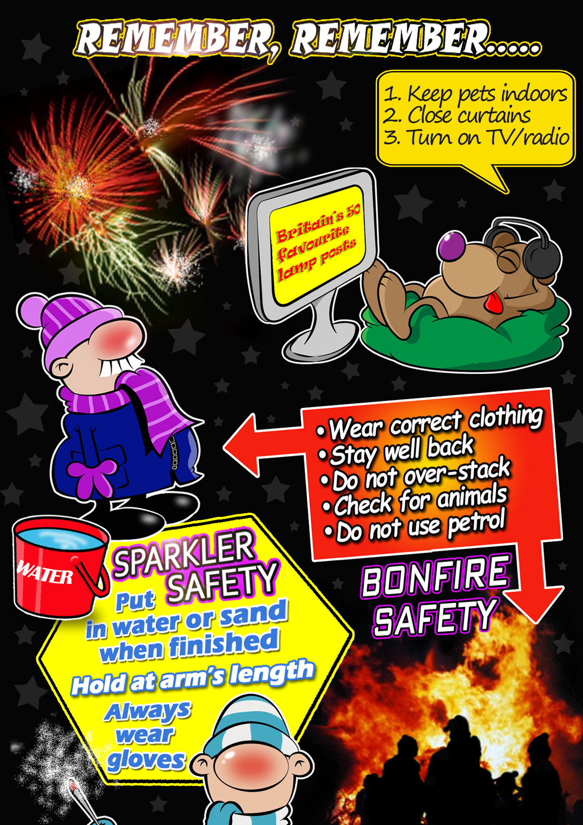 | Interactive jig-saw link:  http://www.epuzzle.info/u/19c474  Available as jigsaw from the above link including leader board displaying fastest time and fewest moves.  A printable version (page7) is also available in this pack to assist pupils in writing down as much of the film messages as they can remember.

Online Evaluations Web-links

Please help us by sparing some time to give us your comments on the activities that we have provided.

We would be very grateful if you could please access the following link to provide feedback for this resource
Year 5 Online Evaluation Link: https://wyfrs.typeform.com/to/rcPJDI

Teacher online evaluation link: https://wyfrs.typeform.com/to/q6ltKP

Thank you!

Interactive jig-saw picture

