**West Yorkshire Fire & Rescue Service**

Job Description.

|  |  |
| --- | --- |
| **POST TITLE:** | Head of People. |
| **GRADE:** | EO2 |
| **RESPONSIBLE TO:** | Director of People and Culture. |
| **PURPOSE OF POST:** | Reporting directly to the Director of People and Culture to support WYFRS with all people related matters across the end-to-end employee lifecycle. Lead the People function, aligning people strategies and policies with the Service’s objectives. Ensure that the Service is enabled by a highly skilled and expert People function, which delivers excellence and puts people at the heart of every decision. To drive cultural evolution and prioritise employee experience. |

# 

# **Organisational chart.**

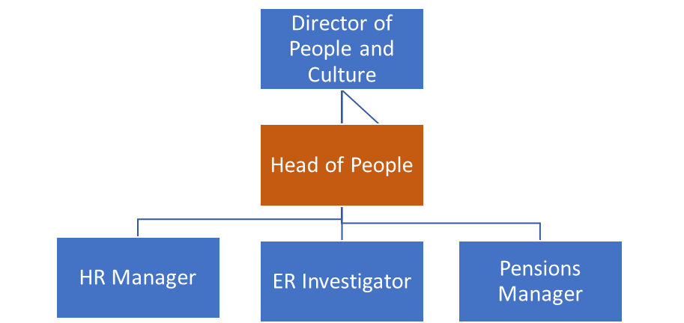

# **Main duties and responsibilities of the role.**

1. Supporting the Director of People and Culture to design and deliver the WYFRS People Strategy to enable the Community Risk Management Plan (CRMP).
2. Providing exemplary strategic and operational leadership to the People, Professional Standards and Pension teams, developing capability, evidence-based practice and embedding an empowered, high-performance culture.
3. Building strong business partnering relationships across the Service to ensure successful delivery of people priorities.
4. Identifying ‘best in class’ people practice within WYFRS, including workforce planning, resourcing, and succession planning to support Service performance and productivity whilst ensuring alignment with National Fire Chiefs Council (NFCC) initiatives and guidance.
5. Leading recruitment, selection, and onboarding of all employees, ensuring a continuous flow of diverse talent into all roles.
6. Leading HR policy and ensuring practice is continuously reviewed in accordance with regulation, employment law, professional/safer recruitment standards and operational demands of the Service.
7. Initiating, preparing, and delivering, as appropriate, reports to Strategic Leadership Team, the People and Culture Committee and internal/external stakeholders.
8. Leading, reviewing, and evolving business partnering arrangements to maximise people service and solution delivery whilst ensuring strategic alignment, influence and efficiency.
9. Driving employee engagement and evolution of WYFRS culture, working closely with the Culture Action Board and colleagues across the Service.
10. Providing timely data insights and management information to facilitate improved individual and organisational performance and enable continuous improvement within short- and long-term budgetary limits.
11. Ensuring agile development, deployment, and implementation of HR systems, where necessary commissioning services from corporate teams and external service providers.
12. Partnering with employee networks and representative bodies, actively involving them in both strategic and operational issues and ensuring appropriate consultation and negotiation arrangements are in place.
13. Leading the pre-employment and DBS checking processes including the recording and monitoring the renewal of high-level checks for Senior Management posts.
14. Overseeing all safeguarding procedures regarding employees by identifying potential concerns, ensuring employees report concerns appropriately, and maintaining staff training on internal safeguarding practices.
15. Championing and integrating Diversity, Equity and Inclusion in every aspect of the role.
16. Managing delegated budgets in line with financial procedures and regulations.
17. Being an active member of Strategic Leadership Team, providing visible day to day leadership and role modelling the NFCC Core Code of Ethics.
18. Supporting the Director of People and Culture to design and implement a directorate operating model fit for the future and develop organisational structures across the Service.

# **Organisational wide responsibilities.**

1. Adherence to the[**NFCC Core Code of Ethics.**](https://nfcc.org.uk/our-services/people-programme/core-code-of-ethics/%20Services%20England.pdf)
2. A satisfactory Standard Disclosure and Barring check is required for the role.
3. This post has been designated a hybrid working post which means the postholder’s working time will be split between the workplace and home. The actual pattern and number of days at each will be agreed locally with the line manager and will be determined based on the service needs.

**Knowledge, skills and experience requirements for this role.**

|  |  |  |  |
| --- | --- | --- | --- |
|  | **Experience** |  | Source. |
| 1 | Experience of leading high performing HR teams that have achieved service excellence and positive people results. | Essential. | Application & Selection Process. |
| 2 | Demonstratable experience of managing complex relations, including direct personal leadership of consultation and negotiation with trade unions. | Essential. | Application & Selection Process. |
| 3 | Experience of leading the development of departmental business plans, including objective setting and performance management of outcome delivery. | Essential. | Application & Selection Process. |
| 4 | Experience in short- and long-term workforce planning and workforce redesign initiatives. | Essential. | Application & Selection Process. |
| 5 | Experience of delivering people focused, transformational change programmes/new operating models inclusive of agile development of systems and platforms. | Essential. | Application & Selection Process. |
| 6 | A proven ability to coach and develop team members and to encourage, enable and support them to reach their potential. | Essential. | Application & Selection Process. |

|  |  |  |  |
| --- | --- | --- | --- |
|  | **Essential Qualifications** |  | Source |
| 7 | Chartered Member or Fellow of the Chartered Institute of Personnel and Development (MCIPD/FCIPD) or equivalent professional HR qualification. | Essential. | Application. |

|  |  |  |  |
| --- | --- | --- | --- |
|  | **Knowledge** |  | Source. |
| 8 | Expert knowledge of current employment legislation, HR issues and the strategic people agenda. | Essential. | Application & Selection Process. |
| 9 | A good understanding of designing, delivering and evaluating people policies, programmes, interventions and strategies. | Essential. | Application & Selection Process. |
| 10 | Practical application of evidence-based practice theory and methodology. | Essential. | Application & Selection Process. |

|  |  |  |  |
| --- | --- | --- | --- |
|  | **Skills** |  | Source |
| 11 | Highly articulate (in writing and orally) with strong engagement and influencing skills. | Essential. | Application & Selection Process. |
| 12 | An empowering, compassionate, collaborative and motivating leadership style with the ability to engage and motivate people to deliver results in line with strategic objectives. | Essential. | Application & Selection Process. |
| 13 | Politically astute and able to navigate organisational politics and culture effectively. | Essential. | Application & Selection Process. |
| 14 | Has strong analytic and critical reasoning skills, is capable of effective problem solving and uses data to drive decision making. | Essential. | Application & Selection Process. |
| 15 | Comfortable with ambiguity, resilient under pressure and can work effectively in a complex environment. | Essential. | Application & Selection Process. |
| 16 | Demonstrates commitment to the values and principles of public service and NFCC Core Code of Ethics in particular. | Essential. | Application & Selection Process. |
| 17 | Driving licence and/or ability to travel between Fire Service properties within West Yorkshire. | Essential. | Application & Selection Process. |

**Indicative Timeline.**

|  |  |
| --- | --- |
| Advert close date (Application and statement of suitability). | Wednesday 21 May. |
| Shortlist. | w/c Monday 26 May. |
| Online Assessments. | w/c Monday 2 June. |
| Stakeholder Panel and Interview. | Thursday 12 June. |