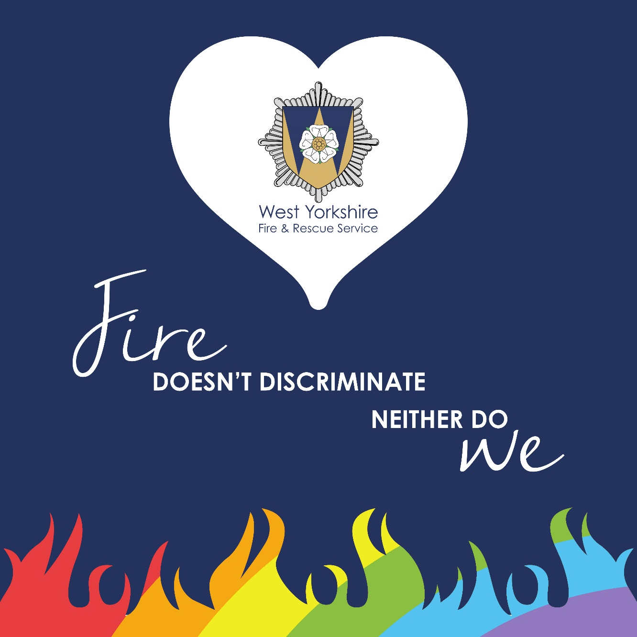

Annual Equality Monitoring Report (2024/25)

Contents

Our Diverse County 3

Why is Diversity and Inclusion important? 4

Why do we collect Equality data? 4

Declaration 4

Summary 5

National Wholetime Statistics 5

Work delivered and plans for 2025/26 6

Data Trends and Comparison 7

Workforce Diversity 8

Gender 8

Ethnicity 11

Sexuality 14

Disability 17

Age 20

Religion 21

Leavers 22

Grievance and Disciplinary 22

# Our Diverse County

2,351,600 people are living in the five metropolitan districts of Bradford, Calderdale, Kirklees, Leeds and Wakefield, within an area of 800 square miles. WYFRS provides fire cover 24 hours a day, every day of the year from its 41 stations and Control Centre.

According to the 2021 Census, 23% of West Yorkshire citizens are Black, Asian, minority and mixed ethnicities. The majority of this population resides in the Bradford region of West Yorkshire which has an Asian population of 20%.

Approximately 18% of the West Yorkshire population are disabled or live with long-term illnesses.

The 2021 census indicated that 40% of the population of West Yorkshire reported they were Christian. This was followed by those who reported no religion (36%). 14.5% of the West Yorkshire population reported that they are Muslim.

3% of people in West Yorkshire identify as Lesbian, Gay or Bisexual.

As with most other counties West Yorkshire has gender parity in its population.

WYFRS has a responsibility to serve our communities, but also to reflect the diversity of the population. Understanding the vulnerabilities and related fire risks facing these diverse groups is paramount in meeting these twin obligations.

# Why is Diversity and Inclusion important?

Diversity and inclusion are central to our core values and bring many benefits to our organisation. Having a diverse and inclusive workforce improves team performance, communication, innovation and wellbeing. An inclusive workforce creates individuals who feel confident, valued and able to deliver the best service to our communities and each other. A host of research indicates that diversity at all levels of the organisation, and crucially in key decision-making roles leads to more innovation, empathy and ultimately increased organisational performance.

We have an organisational, moral and legal responsibility to promote equality and diversity across all of the protected characteristics: race, sex, disability, age, sexual orientation, religion or belief, gender reassignment, marriage and civil partnerships and pregnancy and maternity.

WYFRS promotes equality of opportunity for all by fostering good relations. We work under the Public Sector Equality Duty to eliminate illegal behaviour such as discrimination, harassment and victimisation.

# Why do we collect Equality data?

WYFRS aspires to reflect the diversity of the communities it serves. In order to demonstrate that we are working towards this, we collect equality data and analyse it. We produce this annual report to present the most recent equality data of the WYFRS workforce. We use this data to inform and direct our projects and initiatives including positive action, recruitment, retention, progression, reasonable adjustments and Equality Impact Assessments.

# Declaration

WYFRS rely on employees to input their equality data and share their protected characteristics. This means that we do not have fully accurate data on the demographics of our employees. We are working with all employees to promote the benefits of sharing equality data and how this can influence the work of the organisation.

# Summary

This report presents the equality data of WYFRS’ workforce at 31st March 2025***.*** Reported information includes workforce profiles by age, gender, ethnicity, disability, religion and sexual orientation for Wholetime, Retained, Control and Enabling employees.

At 31st March 2025, WYFRS Workforce diversity is as follows:

* Wholetime roles: 10.3% female, 6% ethnically diverse, 4% Disabled, 5% LGBT.
* On Call roles: 8% female, 2% ethnically diverse, 2% Disabled, 2% LGBT.
* Control: 67% female, 0% ethnically diverse, 7% Disabled, 4% LGBT.
* Enabling Teams roles: 55% female, 9% ethnically diverse, 11% Disabled, 3% LGBT.

There are 2 female Group Managers. Within wholetime only roles we have 1 female in a Station Manager role, 9 female Watch Managers and 13 female Crew Managers. Within operational employees there are 3 ethnically diverse Station Managers, 4 Watch Managers and 8 Crew managers. At strategic decision-making levels there is 33% female representation on WYFRS’s Management Team. At the most senior level, there is a 40% gender split on WYFRS Management Board. We do not have any ethnically diverse employees at this level and we are working with employees to improve promotion and retention initiatives.

The Diversity, Equity & Inclusion (DEI) team have 4 full time employees, 5 employee networks and a number of Diversity and Inclusion champions across the workforce. We have made significant progress in the recruitment of operational employees from underrepresented groups, and we continue to improve and deliver our Positive Action strategy.

# National Wholetime Statistics

We compare favourably with the national sector data for our Wholetime roles. Nationally there are:

* 10% wholetime females.
* 6% wholetime ethnically diverse.
* 5% wholetime LGBT+
* 5% wholetime disabled.

# Work delivered and plans for 2025/26

The Diversity, Equity and Inclusion Team will lead on several projects including the continued implementation of the Diversity and Inclusion Strategy, D&I training review, employee network development and improved partnership working across the five districts. We will continue to review and improve the Positive Action initiatives for the 2025/2026 recruitment drive and implement further measures to improve representation across the Service, including support for internal colleagues from underrepresented groups to gain the skills and knowledge to progress. This year we aim to introduce a race equality plan and a gender inclusion plan, alongside reciprocal mentoring and a digital Equality Impact Assessment process.

Community engagement with underrepresented groups in our communities has been very successful. We have made many more links and partnerships including within the Sikh communities of Leeds, Bradford and Huddersfield. We attended the Gipton and Harehills Unity day, Leeds Learning Alliance and Women at Work events and many more, totalling over 100 engagements within the last 12 months, an increase of over 50%. With the permanent appointment of an additional team member, we will continue to attend more career fairs at schools, colleges and universities. We will continue to attend and celebrate with our communities at our districts Pride events and the Leeds West Indian Carnival.

We are very proud that WYFRS gained Silver accreditation from Inclusive Employers in June 2024, four years ahead of schedule. This means that we are achieving in our ambition to be at the forefront of delivering meaningful projects and processes that ensure diversity, equity and inclusion are at the heart of what we do.

Our employee networks will continue to plan and deliver a number of awareness raising events, including the popular annual ‘West Yorkshire Women of Fire’ event that provides the opportunity for employees to experience all aspects of the role of a firefighter including; Breathing apparatus, road traffic incidents, line rescue and Control appreciation. Our incredible employees network leads and members have been recognised at national awards including AFSA, WFS and Northern Power Women.

# Data Trends and Comparison

The table below shows the 2024/25 equality data for Gender, Ethnicity, Sexuality and Disability alongside previous years.



# Workforce Diversity

## Gender

| **Workforce Profile** | **Commentary** | |
| --- | --- | --- |
|  | Across our Wholetime operational roles women make up 10.3% of employees and is comparative with England FRS data. This is an increase of 1%.  0.5% of employee (2 people) prefer to use their own term to describe their gender. 0.1% of employees are transgender. |
|  | Female on-call firefighters have increased to 8%.  Work continues to promote opportunities for retained firefighters in communities where we have vacancies. | |
|  | Control roles are predominantly filled by female employees. However, we have seen an increase of 1% in male employees. | |
|  | The most equal gender split is within our Enabling Team roles where 55% of employees are female. | |
|  | Across our organisation and across all roles, women make up 22% of our workforce. We recognise that this needs improvement and projects are in place, such as positive action initiatives and training programmes, to address the imbalance. | |

## Ethnicity

| **Workforce Profile** | **Commentary** |
| --- | --- |
|  | Within our wholetime workforce 6% are from black, Asian, mixed and minority ethnic backgrounds. |
|  | The percentage of ethnically diverse on call employees has remained the same as last year. |
|  | Control employees have 0% of employees from a racially diverse background which is a reduction of 4%. |
|  | The representation of ethnically diverse employees within our enabling function has increased by 2%. |
|  | Overall, 6% of the employees demographic are from an ethnically diverse background.  The ethnicity data demonstrates a gap in our workforce diversity, especially considering our diverse community data. Following a successful pilot talent programme, a new programme will be updated and relaunched in the coming months. |

## Sexuality

| **Workforce Profile** | **Commentary** |
| --- | --- |
|  | Wholetime employees have the highest declaration of LGBTQ+ status with 50 members of employees. The declaration rate has improved in all roles demonstrating that employees are becoming more confident with sharing their sexuality in the workplace. We recognise however that a high number of employees have not declared, and we are working on ways to address this. |
|  | The LGBTQ+ representation within on call employees has reduced by 1%. |
|  | Control LGBTQ+ status remains at 4%. This area of the service has the highest declaration rate with only 5 employees members not declaring. |
|  | Enabling Teams employees have 3% identifying as LGBTQ+, which is a reduction of 1% |
|  | The overall rate for all LGBTQ+ employees has remained at 4%. |

## Disability

| **Workforce Profile** | **Commentary** |
| --- | --- |
|  | 4% of Wholetime employees are disabled. The majority of these employees have neurodivergent conditions, such as dyslexia and ADHD, which the service provides assessment for and has support in place. WYFRS use the Access to Work scheme to part fund specific equipment, training and one to one support. |
|  | 3% of on call employees have declared a disability. |
|  | 7% of Control employees have declared a disability, an increase of 3%. |
|  | The highest volume of disabled employees is within the Enabling Teams roles with 11% of employees declaring a disability. |
|  | Across all employees, we have 5% of disabled employees which is an increase of 1%. |

Neurodivergent conditions (dyslexia, ADHD, autism etc.) are categorised as a disability for the purposes of it being protected by equality law. We have screened and assessed a number of employeesover this financial year, and we have implemented support, equipment and training to ensure inclusion in the workplace. We target new recruits through screening and early engagement to ensure they receive full support and workplace reasonable adjustments from the point of entry. We have site licenses for assistive software available to all employees and workplace champions have been identified and trained to deliver bespoke support. We are planning to transition to a social model of inclusion that will be underpinned by universal design.

## Age

|  |  |  |  |  |  |
| --- | --- | --- | --- | --- | --- |
| **March 2023 Data** | **Wholetime** | **On Call** | **Control** | **Enabling Teams** | **Totals** |
| **17 - 24** | 21 | 8 | 4 | 21 | **54** |
| **25 – 35** | 218 | 48 | 7 | 54 | **327** |
| **36 - 45** | 372 | 42 | 12 | 87 | **513** |
| **46 – 55** | 298 | 29 | 14 | 82 | **423** |
| **56 - 65** | 33 | 15 | 10 | 85 | **143** |
| **66+** | 1 | 0 | 1 | 5 | **7** |
| **Totals** | **943** | **142** | **48** | **334** | **1467** |

The majority of our workforce are aged between 36 and 55.

Within operational employees the age profile reduces after the age of 55, which is due in part to the low retirement age of firefighters. The numbers of younger wholetime employees has increased due mainly to the most recent recruitment campaigns and years of zero recruitment due to funding reductions.

There is a more even spread of age profiles amongst on call employees. Recruitment for on call employees is ongoing and regular which allows for a wider representation of ages.

## Religion

Across all employees 25% of employees do not follow a religion or belief. 23% of employees are Christian and 1% are Muslim. 5% of employees have declared ‘other’ and this needs further exploration to see if we need to make more categories available to employees. 45% of employees have not declared.

# Leavers

A total of 119 people left the organisation between 1st April 2024 and 31st March 2025. 52 people left Wholetime roles, 17 left On Call, 3 left Control and 45 people left Enabling Teams roles. 23% of leavers were female, 3% ethnically diverse and 8% were disabled.

# Grievance and Disciplinary

During the 24/25 financial year WYFRS received a total of 12 grievances (6 fewer than the previous year). 1 was upheld, 6 were partially upheld and 5 were not. Of these, 3 were from females and 9 were from males. 2 grievances were from ethnically diverse staff and 10 were from white British / Irish backgrounds.

During the same time period WYFRS conducted a total of 14 formal disciplinary investigations (5 fewer than previous year). Of the 14, 1 was female and 1 was an ethnically diverse employee.