Your Fire and Rescue 2025-28

Foreword
Our Community Risk Management Plan (CRMP) is a three-year strategy aimed at identifying the key risks and challenges facing the communities of West Yorkshire, alongside our strategies to address them.
It includes:
- A compilation of foreseeable fire and rescue-related hazards.
- The deployment of resources for prevention, protection, and response measures.
- Our Service’s priorities, outlining how resources will be allocated to mitigate these risks.
The ambition of West Yorkshire Fire & Rescue Service (WYFRS) is to 'Make West Yorkshire Safer'. To achieve this, we must identify and understand the current and future risks and challenges faced by our local communities.
In West Yorkshire, we manage a diverse range of risks from densely populated deprived areas to rural and isolated communities, and industrial and commercial sites to remote moorland and waterways, all connected by an extensive transport network. In addition to our current risk, we are addressing emerging challenges such as the increasing prevalence of electric vehicles and battery technologies, alongside the impacts of climate change.
Our proactive approach involves continuously adapting to these evolving risks. By staying ahead of these challenges, we ensure that our strategies and resources are effectively aligned to safeguard the community of West Yorkshire.
Through innovation and collaboration, we are committed to maintaining a responsive and resilient service that meets the needs of all residents. Since our last plan was launched in April 2022, we have reached several significant milestones, including:
- Replacing our fleet of fire engines and aerial ladder platforms.
- Redeveloping our main headquarters site in Birkenshaw to deliver a modern energy efficient Headquarters with a purpose built training arena and Spen Valley Fire Station.
- Investing £8m in a replacement mobilising system for Fire Control.
- Introducing lightweight, multi-role personal protective equipment to all operational staff.
- Investment in our Fire Protection resource and capability.
- Increase in the number of firefighters we employ to improve our response.
- Expanding our youth intervention team, allowing us to connect with even more young people across our communities.
- Assessing our protection framework and bolstering our team with additional staff members to strengthen the inspection programme.
- Substantial capital investment in our information and communications technology, enhancing our digital infrastructure.
We will continue working closely with the five local authorities in Bradford, Calderdale, Kirklees, Leeds, and Wakefield, as well as key partners such as West Yorkshire Police and Yorkshire Ambulance Service.
Our objective is to collectively provide the best possible service to all our communities, focusing our fire prevention efforts on safeguarding the most vulnerable.
Our people are vital to our success. Motivated, skilled, and dedicated to making a difference; they serve West Yorkshire with pride. Their dedication to high operational standards helps us accomplish our objectives, while our commitment to continuous improvement ensures the Service's ongoing evolution.
It’s crucial for the Service to understand our communities. One important approach is to build a Service that reflects the diversity of the people it serves, attracting and retaining the best candidates from all backgrounds.
Promoting the values and leadership that define our culture, along with fostering an inclusive workplace where everyone can develop and excel, is central to our future. It's essential that we instil the values we’ve identified as vital for success.
We’re committed to keeping West Yorkshire safe by preventing harm, protecting people, and responding effectively to incidents. We’ll make sure our teams are well-trained, well-equipped, and in the right place at the right time to deliver outstanding service to our communities.
• John Roberts Chief Fire Officer/Chief Executive • Councillor Darren O’Donovan Chair of the Fire Authority

Overview of West Yorkshire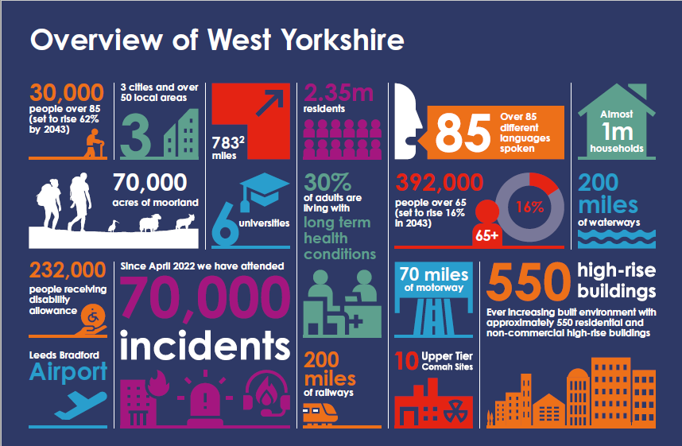

Who we are
We are the statutory emergency fire and rescue service for the metropolitan county of West Yorkshire, England. We are administered by a joint authority of 22 councillors who are appointed annually from the five metropolitan boroughs of West Yorkshire, known as the Fire & Rescue Authority.
We serve a population of more than two million people, spread over 783 square miles, providing emergency cover 24 hours a day, every day of the year.
Our headquarters and training centre in Birkenshaw, is a new state-of-the-art facility.
There are over 1,400 people who work for WYFRS ensuring that we deliver the highest standards of prevention, protection, response and resilience to the communities of West Yorkshire. We have 953 whole-time firefighters, 140 on-call firefighters, 47 Fire Control operators, and 340 support staff, who all contribute daily to 'Making West Yorkshire Safer'.
We operate out of 40 fire stations, located across the five districts: Bradford, Calderdale, Kirklees, Leeds, and Wakefield.
We have 46 Emergency Fire Appliances, 4 Aerial Appliances, a Technical Rescue Unit and a number of resilience appliances available to ensure we are operationally ready whenever needed. We also host a suite of specialist resources that can be deployed anywhere in the UK, including high volume pumps, flood response, wildfire response, urban search and rescue, and response to chemical, biological, radiological, or nuclear hazards.

Why we are here
Our ambition is to Make West Yorkshire Safer. To enhance community safety and wellbeing while minimising the risks to life, property, and the environment from fires and other emergencies.
We work hand-in-hand with our communities to prevent fires and other emergencies, constantly striving to enhance safety and wellbeing. Our initiatives aim to mitigate risks to life, property, and the environment. The unwavering dedication and commitment of our staff has been instrumental in saving numerous lives across West Yorkshire.
The West Yorkshire Fire and Rescue Service operates under several key legislative frameworks that outline our duties and responsibilities. These include:
- The Fire Services Act 2004: Establishes the statutory framework for fire and rescue services, detailing responsibilities for fire safety, firefighting, and emergency response.
- The Civil Contingencies Act 2004: Defines the national framework for emergency preparedness, including response coordination across multiple agencies.
- The Regulatory Reform (Fire Safety) Order 2005: Provides comprehensive guidelines for fire safety in non-domestic premises, focusing on risk assessments and safety management.
- The National Framework 2018: Sets out the government’s expectations and strategic priorities for fire and rescue authorities across the country.
In addition to our statutory duties, we are committed to fostering strong community relationships and undertaking proactive measures to safeguard the residents, businesses, and visitors of West Yorkshire.

Our Strategic Priorities
Your Fire and Rescue outlines our strategy over the next three years. It encompasses six priorities that will guide how we deliver our Service, we will:
- Provide a safe, effective and resilient response to local and national emergencies.
- Focus our activities on reducing risk and vulnerability.
- Enhance the health, safety, and well-being of our people.
- Prioritise a people first mindset through ethical and professional leadership and management
- Work with partners and communities to deliver our services.
- Use resources in an innovative, sustainable, and efficient manner to maximise value for money.
- Further develop a culture of excellence, equality, learning, and inclusion.

Our Achievements
We continuously evaluate our Community Risk Management Planning process to ensure we effectively capture and monitor our progress, performance, and achievements. This ongoing assessment helps us identify areas for improvement, celebrate our successes, and maintain a high standard of service delivery. By doing so, we can adapt to changing risks and ensure our strategies remain effective and relevant.
Some of our achievements include:
- Total incidents down by 5% (25,449) from 2022/23 to 2023/24.
- Deliberate fires down 23% (5,088) from 2022/23 to 2023/24.
- Fires down by 20% (8,741) from 2022/23 to 2023/24.
- Malicious false alarms down 14% (285) from 2022/23 to 2023/24.
- We have invested in a £19.8m fire engine replacement programme which will reduce firefighter exposure to contaminants.
- Lithium-Ion battery training given to firefighters and new equipment introduced to tackle electric vehicle fires.
- Introduced smoke curtains to assist in the management of fire products in building fires.
- Increased our wildfire specialist resources, equipment, Personal Protective Equipment (PPE), training, and capability.
- Our safe and well visits have increased by 4% (12,071) from 2022/23 to 2023/24.
- Our new automated fire alarms policy has reduced calls by 4,700 resulting in approximately 6,700 fewer fire engine
mobilisations.
- Increased on-call fire engine availability from 67% in 2018 to 76% in 2023
- We have recruited and trained 55 new firefighters
- Since October 2018 we have recruited 104 On-call firefighters,14% of these are female.
- We have recruited and inducted 54 new staff into our enabling functions.
- We have reviewed and developed a new administrative support model for fire stations releasing approximately £141,000 to be reinvested into prevention.

How we make West Yorkshire safer
We conduct a strategic risk assessment to evaluate all risk affecting our communities to support our aim of Making West Yorkshire Safer.
We put in place arrangements to prevent and mitigate identified risks, either through adjusting existing provision, effective collaboration and partnership working, or developing new capability.

Understanding and assessing risk
The term risk generally refers to the possibility of something bad happening; something with the potential to cause harm. It involves uncertainty about the effects or implications of an activity, often focusing on negative, undesirable consequences.
To manage risk, our strategic risk assessment methodology is regularly updated, ensuring we are prepared for all foreseeable emergencies. This process aligns with the National Risk Register, and the West Yorkshire Community Risk Register.
We will continue to learn from significant events, whether they are local, regional, national, or international.

Understanding and assessing vulnerabilities within our communities
Vulnerability
Societal trends are resulting in a growing number of vulnerable individuals increasing the risk within our communities. These trends include:
- People living longer.
- Increasingly complex health needs, including mental health.
- Deprivation and the rising cost of living.
- Expanded community care.
These factors are central to our efforts in identifying the most vulnerable individuals within our communities to mitigate fire risks. By utilising data from various sources, we can pinpoint the areas with the highest vulnerability. This enables us to focus our prevention activities on those most at risk.

Resourcing to our current and emerging risk
We use a data driven approach to ensure our fire engines and specialist resources are located and staffed to provide the optimal level of emergency cover based on local risk.
WYFRS Stations:
- Wholetime Stations - 24/7 availability from the station
- Day Crewing – On station during the day, respond from home at night (On-Call)
- On-Call – Respond from home or place of work during the day and night
Risk Band | Risk to life | Risk to property | Other
Very high risk | 7 minutes | 9 minutes | 15 minutes
High risk | 8 minutes | 10 minutes | 15 minutes
Medium risk | 9 minutes | 11 minutes | 15 minutes
Low risk | 10 minutes | 12 minutes | 15 minutes
Very low risk | 11 minutes | 13 minutes | 15 minutes
Planned response times

We currently achieve a 93% success rate in meeting our planned response times. We continuously monitor our performance against risk-based planning assumptions to help us maintain a safe and effective response, ensuring we continually improve our service delivery.

What we deliver
We deliver our services through Prevention, Protection, Response and Resilience strategies, which are central to our ambition of ‘Making West Yorkshire Safer’. These strategies help us stay prepared and protect our community.

Prevention
Raising awareness about the risks people face to prevent emergencies and reduce vulnerability.
Our firefighters conduct prevention activities when they are not attending or preparing for emergencies. Data and intelligence guide local decision-making, enabling a more agile response to any changes in risk at district level. For more complex cases, we employ specialist prevention staff who collaborate with our partner agencies to reduce risk within our communities.
Our resources are distributed across the county based on risk factors. Our prevention initiatives are specifically targeted to meet the needs of the most vulnerable.
Our Corporate Communications Team plays a crucial role in promoting our prevention campaigns, ensuring our message reaches the most vulnerable members of the community.
Prevention efforts extend beyond the home; for instance, we work with young people in schools and community groups to keep them safe from fire, road traffic collisions, and water hazards. Prevention Strategy 2025-28 (link to be added)

Protection
We promote and enforce fire safety measures required by law to ensure buildings and occupants are protected in the event of a fire. We enforce the Regulatory Reform (Fire Safety) Order 2005, which applies to nearly every building except single private homes.
We have invested in our Fire Protection Team, allowing us to allocate the right resources to the areas most at risk. We ensure our inspecting officers have the capacity to address new and emerging risks within West Yorkshire. Our Risk-Based Inspection Programme uses data and information to direct our resources to premises that present the greatest risk to occupants in the event of a fire.
Our dedicated team consists of qualified and experienced fire safety officers who provide advice, support, and investigate complaints related to poor fire safety. Through our initiatives and statutory methods such as enforcement and licensing, we ensure that every premise our inspectors visit is safer when they leave.
By partnering with local authorities, we support building regulations to ensure new buildings incorporate relevant fire safety measures. We recognise that engaging with businesses is crucial to helping them fulfil their fire safety responsibilities, thereby supporting local economic growth. Our recently introduced Business Fire Safety Advisor roles are designed to not only provide a mechanism to engage with all types of businesses, but they also provide us with a robust team now and in the future. Enabling progression of Advisors to Inspectors ensures the long-term sustainability of the team, ensuring we continue to support our communities.
We focus the majority of our protection work at higher risk premises; these may be higher risk due to the complexity of the building, or due to the occupants within it. One key area we will continue to focus on is buildings with external wall defects that require remediation. We work with Local Authorities, West Yorkshire Combined Authority the Ministry of Housing, Communities and Local Government and the newly formed Building Safety Regulator to ensure those responsible for remediating defects, do so in a timely manner.
In addition to this, our Fire Protection Team enforces legislation for the storage of petroleum-spirit by issuing certificates for petrol stations and licenses for the storage of explosives and fireworks. We have and will continue to introduce measures to reduce the impact and likelihood of fireworks being used in an anti-social manner, working with government and local partners to tighten legislation and licensing procedures in this area. Our efforts to reduce persistent false alarms have led to a significant decline in numbers over the past 10 years, and this trend continues. Protection Strategy 2025-28 (link to be added)

Response
Preparing for and responding to emergencies.
Our Fire Control handles all 999 emergency calls, with operators assessing each call to determine the necessary emergency response. Fire Control dispatches the fire engine(s) or specialist resource(s) that can respond the quickest to the emergency.
The combination of our response time and the number of firefighters attending a fire is crucial. More serious and complex emergencies typically require more firefighters, a strategy we refer to as our ‘speed and weight of attack.’
We aim to maintain the current number of fire stations and fire engines to preserve our existing ‘speed and weight of attack.’
Each station operates a shift system based on the local community’s risk level. Higher-risk areas are covered by wholetime (24/7) stations, while lower-risk areas are covered by on-call stations. Areas with intermediate risk levels have a combination of both, with day-crewed stations (working during the day and on-call at night).
Our 46 fire engines are equipped to handle most emergencies. For more complex emergencies, we have strategically located specialist resources available.
When a fire engine is unavailable due to an emergency or operational training, we have systems and procedures in place to relocate other fire engines to maintain a high standard of cover where it is most needed, according to risk.
To ensure the nearest fire engines respond to emergencies near and across our county border, we have arrangements with neighbouring Fire and Rescue Services to share fire engines and other specialist resources as required.
Response and Resilience Strategy 2025-28 (link to be added)

Operational Preparedness
To ensure we are safe and effective in our operational response, we invest time and resource into our operational preparedness. This involves developing up to date operational guidance, gathering risk information on high risk buildings and sites, investing in state of the art equipment and fire engines, as well as training and exercising to the risks we face in our communities.
Operational Training
Our operational training is comprehensive and designed to ensure firefighters are well-prepared for a wide range of emergencies. Here are some key components of this training:
- Core Skills Training: This includes fundamental firefighting skills such as hose handling, ladder operations, search and rescue techniques, and the use of breathing apparatus. These skills are essential for effective firefighting and rescue operations.
- Specialised Training: Firefighters receive training in specialised areas such as hazardous materials, technical rescue (e.g. rope rescue, confined space rescue), driving, and water rescue. This ensures they can handle specific types of incidents safely and effectively.
- Incident Command Training: This focuses on developing the skills needed to manage and coordinate emergency responses. It includes training on decision-making, resource management, and communication during incidents.
- Live Fire Training: Our firefighters participate in controlled live fire exercises to practice their skills in realistic scenarios. This helps them understand fire behaviour and develop the ability to operate safely in high-stress environments.
- Continuous Professional Development: Firefighters engage in ongoing training and development to keep their skills up to date. This includes refresher courses, new techniques, and learning from past incidents.
These training programmes are crucial for maintaining high standards of operational readiness and ensuring the safety and effectiveness of our response.
Our firefighters engage in a variety of training programmes beyond operational training to ensure they are well-rounded and prepared for all situations. Here are some key areas of training:
- Community Safety and Education: Firefighters provide educational programmes in schools and community groups to teach fire safety, prevention, and inform about emergency response.
- Safe and Well Visits: Firefighters are trained to visit homes offering a person-centred approach to reduce the risk of fire.
- Technical Skills: Firefighters receive continuous training on the use of new equipment and technologies, as well as maintaining and testing existing equipment to ensure operational readiness.
- Multi Agency and JESIP training: Our firefighters undertake training with our blue light partners, local authorities and other key organisations (utility companies, transport organisations, etc) to ensure operational understanding and development.

Training Centre
Our state-of-the-art training centre, staffed by highly skilled professionals, ensures that all personnel acquire the essential skills, knowledge, and competencies to perform their duties safely and effectively. We offer comprehensive training programmes, continuous professional development opportunities, and specialised courses tailored to the diverse needs of our service. Our objective is to uphold and maintain the highest standards of operational readiness and to cultivate a culture of continuous improvement and excellence in service delivery.
Resilience

Managing Major Emergencies and Disruptions
We can handle most emergencies with our own fire engines and firefighters. However, major incidents sometimes require support from other Fire and Rescue Services. We have measures in place to call upon additional support when needed.
Nearly all serious emergencies require a multi-agency response. By collaborating with our partner agencies in West Yorkshire, we can respond with the right mix of skills, expertise, and equipment to address the risks we face.
We operate in accordance with the Joint Emergency Services Interoperability Principles (JESIP) to ensure effective collaboration with West Yorkshire Police, Yorkshire Ambulance Service, and our other partner agencies during serious and major emergencies.

National Resilience Assets

We maintain a full suite of specialist resources that can be deployed anywhere in the UK. Similarly, we can call upon specialist resources hosted elsewhere in the country to respond in West Yorkshire. We have agreements in place to share these resources when needed, and we consider our national commitments when making local plans.

Business continuity
Business continuity management is a crucial aspect of West Yorkshire Fire & Rescue Service’s risk management strategy, addressing both internal disruptive events and external emergencies such as extreme weather, flooding, terrorism, and infectious diseases. This approach ensures that essential public services are maintained without interruption. It empowers staff to make swift, informed decisions to effectively respond to disruptions, thereby minimising the impact on us and our operations.
Regular testing and exercising of business continuity plans and related arrangements enhance our risk awareness and improve the likelihood of successful plan implementation. This ensures we can continue to function effectively during and after any disruptive events.

Local Resilience Forum
We recognise that the causes and consequences of fires and other emergencies cannot be addressed by the Fire and Rescue Service alone. Therefore, working in partnership with other agencies is fundamental to how we deliver services at all levels and in all areas; partnership working is considered part of our core business.
As a member, WYFRS plays a key role in the West Yorkshire Local Resilience Forum (West Yorkshire Prepared), established under the Civil Contingencies Act 2004. West Yorkshire Prepared coordinates the actions and arrangements between responding services to prepare for and respond to civil emergencies. It also assists people and communities in recovering after adverse events. Our partners work collaboratively for the benefit of the communities we serve.
Response and Resilience Strategy 2025-28 (link to be added)

Collaboration and partnership working
We understand the benefits of collaboration and work closely with partners such as regional fire and rescue services, local authorities, emergency services, health teams, community groups, and voluntary organisations to identify and support the most vulnerable individuals in our communities.
By seeking out collaborative opportunities, we have been able to find possibilities to share estates with West Yorkshire Police and Yorkshire Ambulance Service. This has provided opportunities for joint training, combined community engagement opportunities and better multi-agency working. This collaborative effort supports more cohesive service delivery, achieves better value for money, and facilitates more effective planning for emergencies and pre-planned events..

How we deliver these services
District Teams
To help deliver these services, we have five District Teams, each creating a tailored local action plan:
- Bradford District Plan
- Calderdale District Plan
- Kirklees District Plan
- Leeds District Plan
- Wakefield District Plan
These plans are designed to address the specific needs and risks of each district, ensuring that our resources and efforts are effectively targeted to enhance community safety and well-being.
Fire Control
Fire Control are essential in managing emergency situations, providing 24/7 coverage to coordinate responses to all types of emergencies. Answering 999 calls is just the beginning of their crucial role. Our control operators:
- Handle Emergency Calls: They help callers identify the exact location of incidents and provide safety advice and reassurance over the phone until firefighters arrive on the scene.
- Dispatching Resources: They quickly and efficiently dispatch the appropriate resources to the incident.
- Maintain Communication: They maintain constant communication with teams on the fireground to help manage incidents effectively.
- Coordinate Responses: They communicate with other emergency and non-emergency responders to ensure a coordinated response.
- Manage Fire Cover: Ensure resources are mobilised efficiently and effectively.

Enabling our service
Our enabling functions deliver crucial services across multiple areas, playing a vital role in the delivery of our service.

- Committee Services

- Corporate Communications
- Corporate Services
- Digital Data & Technology
- Employee Resourcing
- Finance & Procurement
- Human Resources
- Legal Services
- Occupational Health, Safety and Wellbeing
- Organisational Development & Learning
- Estates
- Service Improvement and Assurance
- Strategic Development
- Transport & Logistics

People and Culture
We employ 1,466 dedicated staff members who contribute to promoting safety and well-being across all communities in West Yorkshire.
We acknowledge the crucial role our workforce plays in achieving our ambition. As one of the country’s leading Fire & Rescue Services, we are committed to supporting and developing our personnel and investing in their future.
Our People and Culture Strategy offers a strategic framework that aligns with the service’s aim and priorities. It ensures we have the right people with the necessary skills, in the right positions, at the right time.
- People and Culture plan to be added

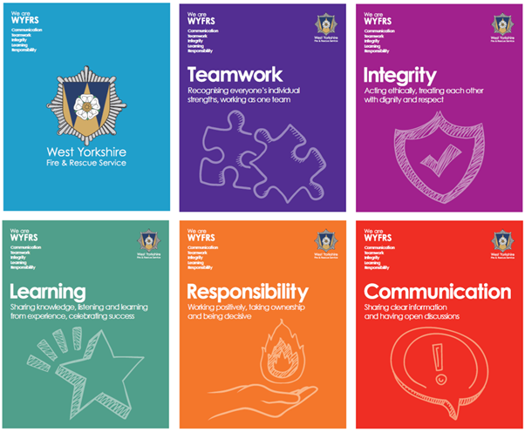
Our values
‘Our Values’ complement the new National Fire Chiefs Council Core Code of Ethics, which prioritises the interests of the public, the community, and service users.
Teamwork “We recognise everyone’s strengths and contributions, working effectively as one team.”
Integrity “We are trustworthy, act ethically, treating each other with dignity and respect.”
Learning “We learn all the time; we share knowledge and experiences, celebrating success.”
Responsibility “We are responsible, work positively and take ownership of the work we do.”
Communication “We share clear information, in ways everyone understands, having open discussions”
We strive to create an inclusive environment where every individual feels valued and supported.

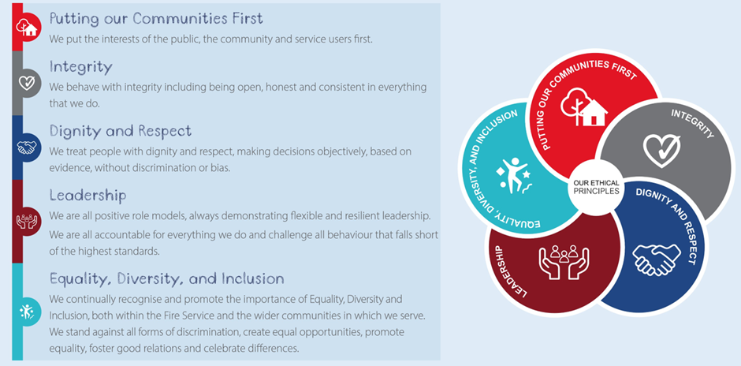
Core Code of Ethics
Our Core Code sets out five ethical principles, based on the Seven Principles of Public Life, which provide a basis for promoting good behaviour and challenging inappropriate behaviour.
- Putting our communities first – we put the interest of the public, the community and service users first.
- Integrity – we act with integrity, including being open, honest and consistent in everything we do.
- Dignity and respect – making decisions objectively based on evidence, without discrimination or bias.
- Leadership – we are all positive role models, always demonstrating flexibility and resilient leadership. We are all accountable for everything we do and challenge all behaviour that falls short of the highest standards.
- Equality, diversity, and inclusion (EDI) – We continually recognise and promote the value of EDI both within the FRSs and the wider communities in which we serve. We stand against all forms of discrimination, create equal opportunities, promote equality, foster good relations, and celebrate difference.
Organisational Development and Learning
Organisational learning is a key component of our strategy to enhance organisational effectiveness and safety. Here are some insights into how we approach it:
Learning & Development - Focuses on helping everyone gain the knowledge and skills needed to perform their current jobs well, develop personally, and prepare for future roles. This includes supporting firefighters to achieve competence, ensuring the promotions process is fair and transparent, and developing knowledge, skills, and supporting behaviours.
Diversity, Equity & Inclusion - Involves making the most of people’s experiences, backgrounds, and talents, ensuring everyone has what they need to be at their best, and creating an inclusive environment where everyone feels valued and respected.
Organisational Development - Focuses on positively changing the culture within our service moving towards a workplace that employees want to work in. It involves taking real actions to address the feedback from staff and continuously improving the working environment.
Workshops & Training - We conduct workshops and training sessions to ensure that staff are well-prepared and knowledgeable.
Feedback & Continuous Improvement - We place a strong emphasis on feedback and continuous improvement. We encourage staff to provide feedback on their experiences and use this information to make informed decisions and improvements.
We deliver a comprehensive programme of learning and development for everyone in our service:
Management & Leadership Development - We provide comprehensive development to support new and experienced managers. This includes short programmes on key people topics and apprenticeships in management at Levels 3, 5 and 7. We have integrated management skills within our promotion framework.
Apprenticeships - We support people in operational and enabling services to achieve appropriate professional qualifications through our comprehensive programme of apprenticeships.
Skills Development - We provide learning opportunities in a wide range of topics, including influencing, managing conflict, change, health & safety, wellbeing and coaching to name but a few.
Organisational learning and development is about creating a culture of continuous improvement, where knowledge is shared, and everyone is encouraged to learn and grow. This approach helps us adapt to new challenges and improve our overall safety and effectiveness.

Occupational Health, Safety, and Wellbeing
- Our specialist Occupational Health Department is dedicated to promoting and maintaining the physical and mental wellbeing of all staff members, ensuring that our workforce remains healthy, safe, and fit for duty.
- Our work to support our ageing workforce will include horizon scanning, along with the identification of policy, research, and impact on health and safety. We will promote a positive health and wellbeing culture where staff feel in control of their own welfare.
- Our fire appliances and personal protective equipment are designed to minimise exposure to hazards and contamination.
- Our unwavering commitment to health, safety, and wellbeing ensures that our personnel are well-equipped to perform their duties effectively, thereby enhancing the overall safety and efficiency of our service.

Finance and Procurement
Our services are funded by taxpayers, and we have a legal duty to ensure that the services we provide offer value for money and meet the needs of an ever-changing society. With an annual budget of £117.197 million, we are committed to delivering the best affordable service for our communities. The chart opposite offers a detailed analysis of our funding sources.
By implementing smarter working practices and introducing an improved budget management system, we have achieved a balanced budget. This means our expenditure matches our funding, eliminating the need to use any of our reserves. Additionally, we continuously seek ways to optimise our resources and improve efficiency, ensuring that we can maintain high standards of service while being fiscally responsible.
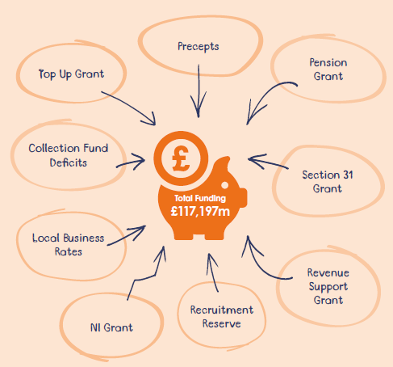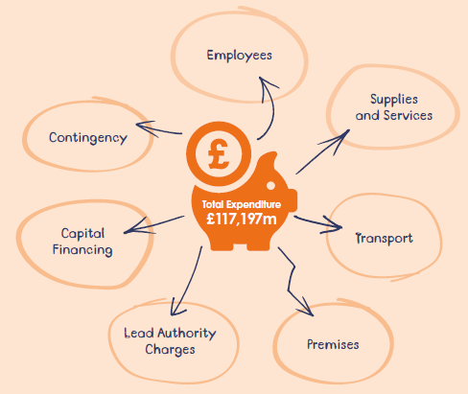
By implementing smarter working practices and introducing an improved budget management system, we have achieved a balanced budget. This means our expenditure matches our funding, eliminating the need to use any of our reserves. Additionally, we continuously seek ways to optimise our resources and improve efficiency, ensuring that we can maintain high standards of service while being fiscally responsible.

Value for Money
We contribute significant social and economic value through our responses to fire and non-fire emergencies, as well as our prevention and protection activities. At fire-related incidents, we prevent further property damage. Additionally, we prevent injuries, save life and protect the environment.
Our prevention and protection activities encompass Safe and Well visits, audits and inspections of commercial premises, and fire setter and antisocial behaviour schemes. Each of these activities has been calculated to provide a positive social return on investment.

Efficiency and Productivity
As part of the 2021/22 Spending Review, the National Fire Chiefs’ Council and the Local Government Association proposed that Fire and Rescue Services in England could achieve 2% non-pay efficiencies and increase productivity by 3% by 2024/25.
Our Efficiency and Productivity Plan outlines how the West Yorkshire Fire and Rescue Authority aims to deliver these efficiencies and increase productivity to meet the national targets set for the 2021/22 - 2024/25 spending review period.

Procurement
The Authority leads on the regional Yorkshire and Humber procurement group where procurement pipelines and contract registers are regularly reviewed to facilitate collaborative purchasing. The Authority uses where it is economically advantageous to do, national framework agreements, thus ensuring that value for money is maximised.

Assets and Environment
The impact of climate change and the increase in extreme weather conditions, such as heatwaves and flooding, continue to affect the number of environmental incidents we attend. We are committed to balancing the environmental, social, and economic impacts of our activities and will continue to promote environmentally friendly practices.
In recent years, we have taken significant steps to reduce carbon emissions by introducing electric cars into our vehicle fleet. Our new Headquarters site has been designed to accommodate home working patterns, while also rationalising our estate by relocating our Service Delivery Centre and Cleckheaton Fire Station to the same site.
When redeveloping existing premises or designing new buildings, we will ensure that we maximise opportunities to reduce carbon emissions and improve energy efficiency across our estate. Additionally, we are exploring innovative solutions and technologies to further minimise our environmental footprint and enhance sustainability in all aspects of our operations.

Transport & Logistics
Our Transport and Logistics department is a crucial component of West Yorkshire Fire & Rescue Service’s operational and non-operational activities, initiatives, and services.
The department focuses on continuous improvement and innovation, ensuring that our logistics and transport solutions are efficient, sustainable, and aligned with the latest industry standards. This commitment helps us enhance our overall service delivery and readiness to respond to any emergency.
We’ve committed around £19.8 million to acquire 52 new Scania and 6 new MAN fire engines. These additions will introduce major advancements, enhancing safety while prioritising the reduction of long-term exposure to carcinogenic substances.

Estates
Our Estates department plays a vital role in managing and maintaining our physical assets and facilities. Their work is essential to maintaining the infrastructure that supports our ambition of ‘Making West Yorkshire Safer’, ensuring that all facilities and assets are ready to support both everyday operations and emergency responses.
Estates Strategy 2021-2026 .pdf
New Fire Service Headquarters
Our Birkenshaw site, central to the county, comprises of the Fire Service Headquarters, Training and Development Centre, and Spen Valley Fire Station.
This state-of-the-art Fire Service Headquarters provides the support functions for our 40 fire stations. In support of our sustainability efforts the new building has over 250 solar panels, heat pumps, hybrid ventilation and electric vehicle charging.
New employees, including trainee firefighters, start their journey with WYFRS at our headquarters site. The Centre also plays a vital role in ensuring our firefighters' knowledge and skills remain current and relevant, to meet the demands of the risks in West Yorkshire.

Fire Station Design
In 2020, we launched a project to determine the optimal fire station designs to meet the Service’s long-term needs. We developed a set of ‘Fire Station Design Principles’ that are now applied to both new and existing fire stations. These principles focus on health and safety, diversity, and inclusion, building suitability, and spatial relationships. They aim to minimise environmental impact and incorporate a zoning layout to reduce exposure to contaminants..

Digital Data & Technology
The Digital, Data and Technology department’s work is integral to the smooth operation of West Yorkshire Fire & Rescue Service, ensuring that technology enhances the effectiveness and safety of all personnel. Our specialist team provides technical support for hardware and software issues. They play a crucial role in ensuring that technology supports all aspects of operations, and that all systems are functioning correctly and efficiently. They continuously investigate, evaluate and implement new technologies to improve service delivery.
Our Digital and Data Strategy outlines our digital investment, focusing on equipping our service with the right systems, technology, and data. We are constantly improving and updating our digital infrastructure to adapt to changing requirements and integrate the latest technological innovations. This enables us to evaluate how these digital systems can better support and improve the transformation and delivery of our services to employees, partners, and the community.
We aim to future-proof our data collection and analysis processes, allowing us to make informed decisions about identifying and addressing risks and vulnerabilities within our communities. Access to accurate, real-time information and data will drive change and continuous improvement, while also increasing productivity across all areas of the service.
Our newly implemented performance management system is now delivering substantial benefits, ensuring transparency and accountability. It serves as a platform to share data with our fire service colleagues, partner agencies, and the communities of West Yorkshire.
The integration of Artificial Intelligence in the fire service brings numerous advantages, such as data-driven decision making, predictive analytics, and enhanced situational awareness. These improvements significantly boost both efficiency and safety.
Digital and Data Strategy (to be added)

Corporate Services
We have a Service Assurance Framework in place to ensure we meet our commitments and adhere to the expected standards. This framework plays a crucial role in our annual statement of assurance, demonstrating our compliance with the National Framework 2018.
The Service Assurance Framework helps us identify areas for improvement and ensures that we continuously enhance our service delivery. By regularly reviewing our performance against these standards, we can maintain high levels of accountability and transparency, ensuring that we consistently meet the needs and expectations of our communities.
To ensure we deliver the best service to our communities, we are annually assessed against the Government’s Customer Service Excellence standard, which is derived from the core concepts of customer focus and the delivery of excellent customer service. We are fully compliant with the standard including many areas where we exceed the requirements and are viewed as exceptional or as exemplar for others, demonstrating our commitment to providing an excellent service to customers.
Link to corporate services strategy to be added

Transformation and Innovation
We have reviewed our achievements and performance over the last three years. To achieve our ambition of ‘Making West Yorkshire Safer,’ we will not stand still. We are committed to continuous learning, adaptation, and improvement in all our activities. Our dedication to excellence is unwavering, and we are constantly exploring new methodologies and incorporating feedback to refine our processes.
By embracing innovation and best practices, we aim to stay ahead of emerging challenges and ensure that our services remain effective and responsive to the needs of West Yorkshire. We conduct regular training sessions for our staff to enhance their skills and knowledge, allowing them to better serve our community. Furthermore, we invest in advanced technologies and tools that enable us to perform our duties with greater precision and efficiency.
In our pursuit of continuous improvement, we make it a priority to engage with the community, gathering their insights and concerns to better understand their needs. This collaborative approach ensures that our strategies and initiatives are aligned with the expectations of those we serve. We also work closely with partner agencies and stakeholders, fostering strong relationships that contribute to a coordinated and comprehensive approach to public safety.

Programme of change
The Programme of Change is overseen by the WYFRS Portfolio Management Office, which plays a central role in aligning project delivery with organisational strategy. It acts as a Centre of Excellence providing governance, oversight, and support for project and programme management across the service.

HMICFRS
His Majesty’s Inspectorate of Constabulary and Fire & Rescue Service (HMICFRS)
HMICFRS continues to focus on how effective and efficient fire and rescue services are at carrying out their principal functions, and how well they look after their people.
Inspections are conducted based on three pillars: Efficiency, Effectiveness, and People, covering the 44 Fire and Rescue Services in England and Wales. The findings are reported to provide insights into each service’s performance.
The table opposite captures gradings from our recent HMICFRS inspection. A full breakdown of the report can be found here..
We are continuing to ensure that the HMICFRS standards and inspection frameworks act as guiding principles for our service delivery, ensuring that we align with national expectations on prevention, protection, response and resilience. The Service Improvement and Assurance Team (SIAT) leads WYFRS’s preparation for HMICFRS inspections. This includes gathering evidence, coordinating document submissions, facilitating fieldwork, and supporting self-assessment.

Annual State of Fire Report
The 2023 assessment highlights steady progress across fire and rescue services in England, particularly in operational effectiveness and public safety. However, it also identifies ongoing challenges in areas such as values and culture, staff misconduct, and leadership consistency. The report draws on inspections conducted between January 2023 and March 2024 and includes reflections on sector-wide improvements since 2018
https://hmicfrs.justiceinspectorates.gov.uk/publications/state-of-fire-and-rescue-annual-assessment-2023/

National Fire Standards
The National Fire Standards Board has established professional standards to drive continuous improvement across the fire sector. These standards are essential for all Fire & Rescue Authorities in England to implement. HMICFRS use these standards in their inspections.
We are committed to regularly reviewing and updating our practices to align with the latest Fire Standards. This proactive approach helps us maintain high levels of service and safety, ensuring we are always prepared to meet the needs of our communities effectively.
https://www.firestandards.org/

